Deputy Minister of Economy

Artyom

Zdunov

Republic of Tatarstan

Investments in the Republic of Tatarstan
(billion US dollars)
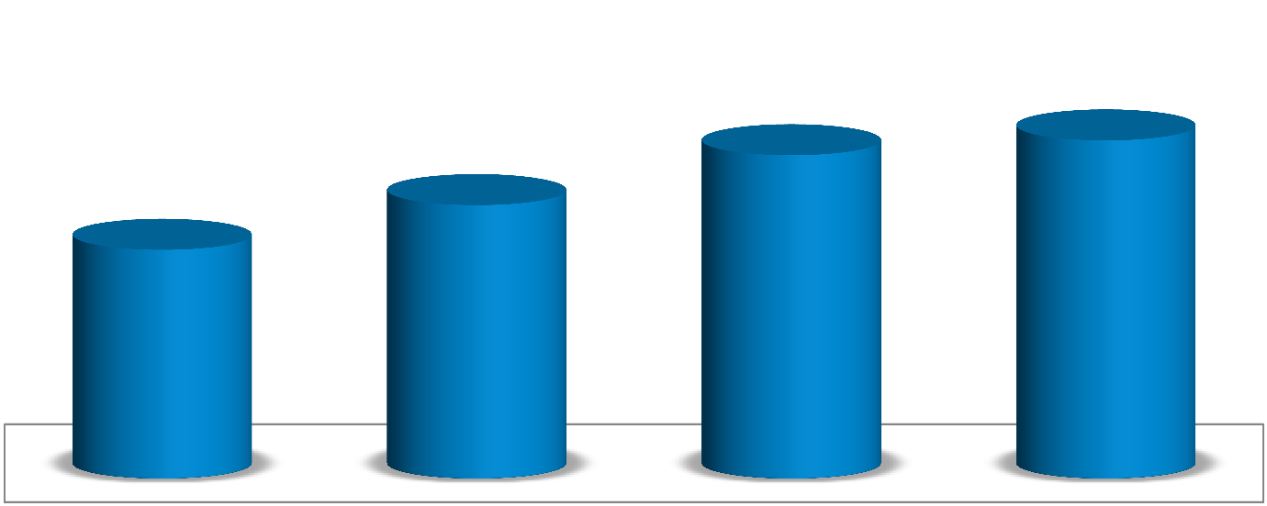
10
8
,
7
%

2010
2011
2012
2013
96
,
10

13
,
10

49
,
15

20
,
16

113,6
%

108,7
%

106,8
%

109,9
%

forecast

For 2011 - (first half) 2013 in the fixed capital investments in the Republic of Tatarstan amounted to 32 billion dollars

Investment ratings
- Fitch:
Fitch upgraded Republic of Tatarstan to
'BBB'; Outlook Stable

- Forbes:
Tatarstan is at the top of “top 30 regions in Russia attractive for doing business” list.

- Ernst & Young:
Tatarstan is the most favorable region for doing business in Russia.

Development institutions
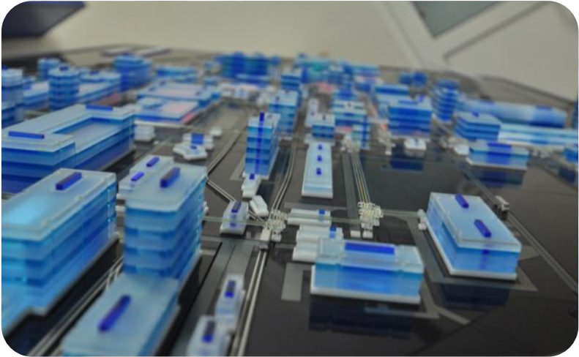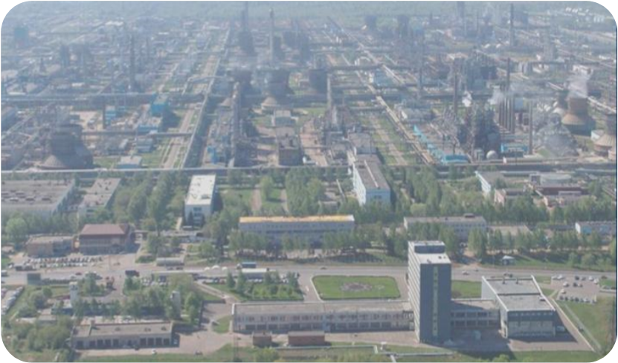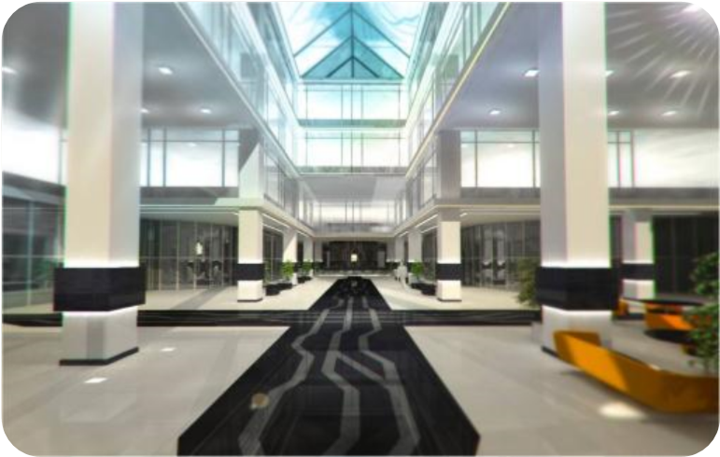
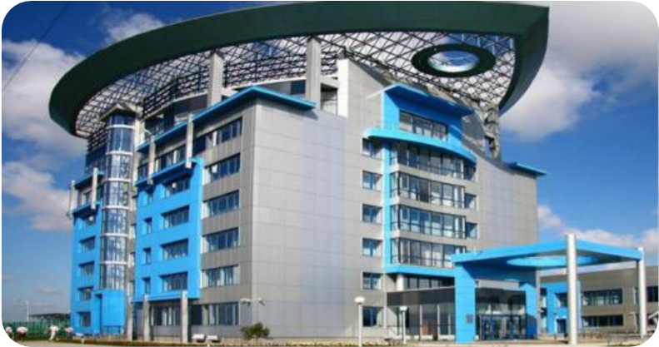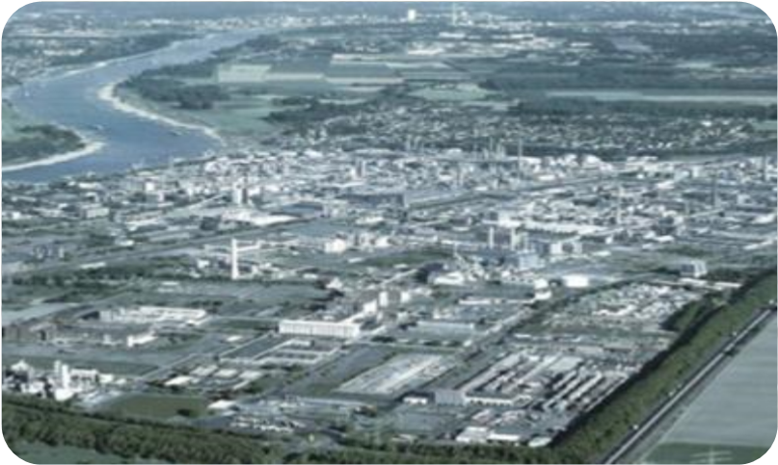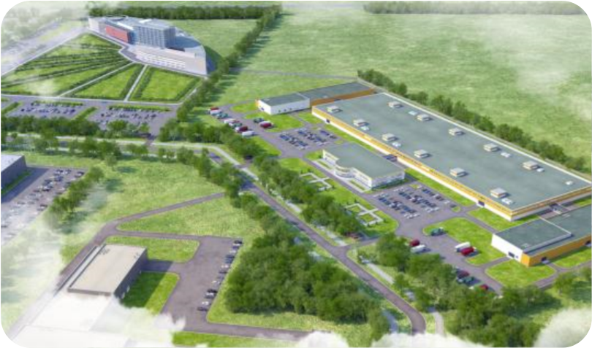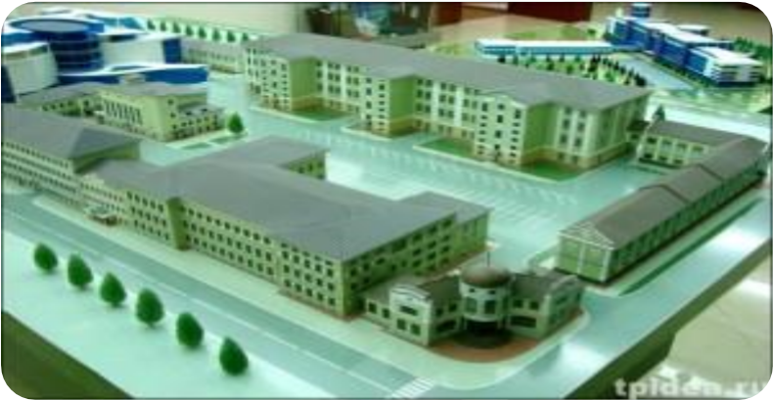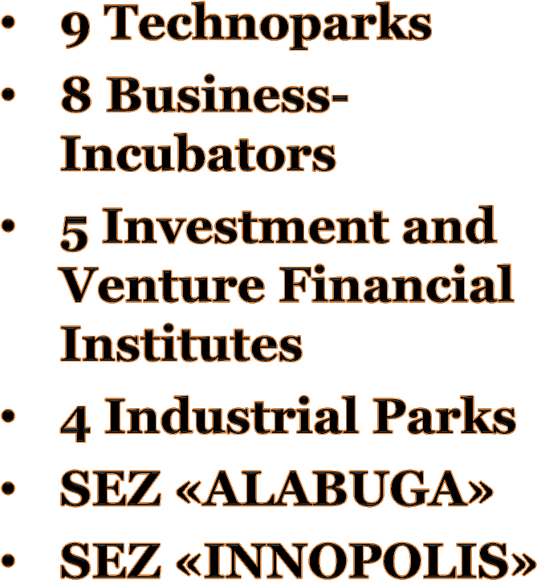

Technopolis

«
Khimgrad
»

Special Economic
Zone
«
ALABUGA
»

Kamskiy

Industrial
Park

«
MASTER
»

Industrial Park

«
Kamskiye

Polyani
»

IT
-
park

Industrial park
«
Chistopol
»

Innovation
Technopark

«
IDEA
»

Kamskiy innovation territorialand-production cluster
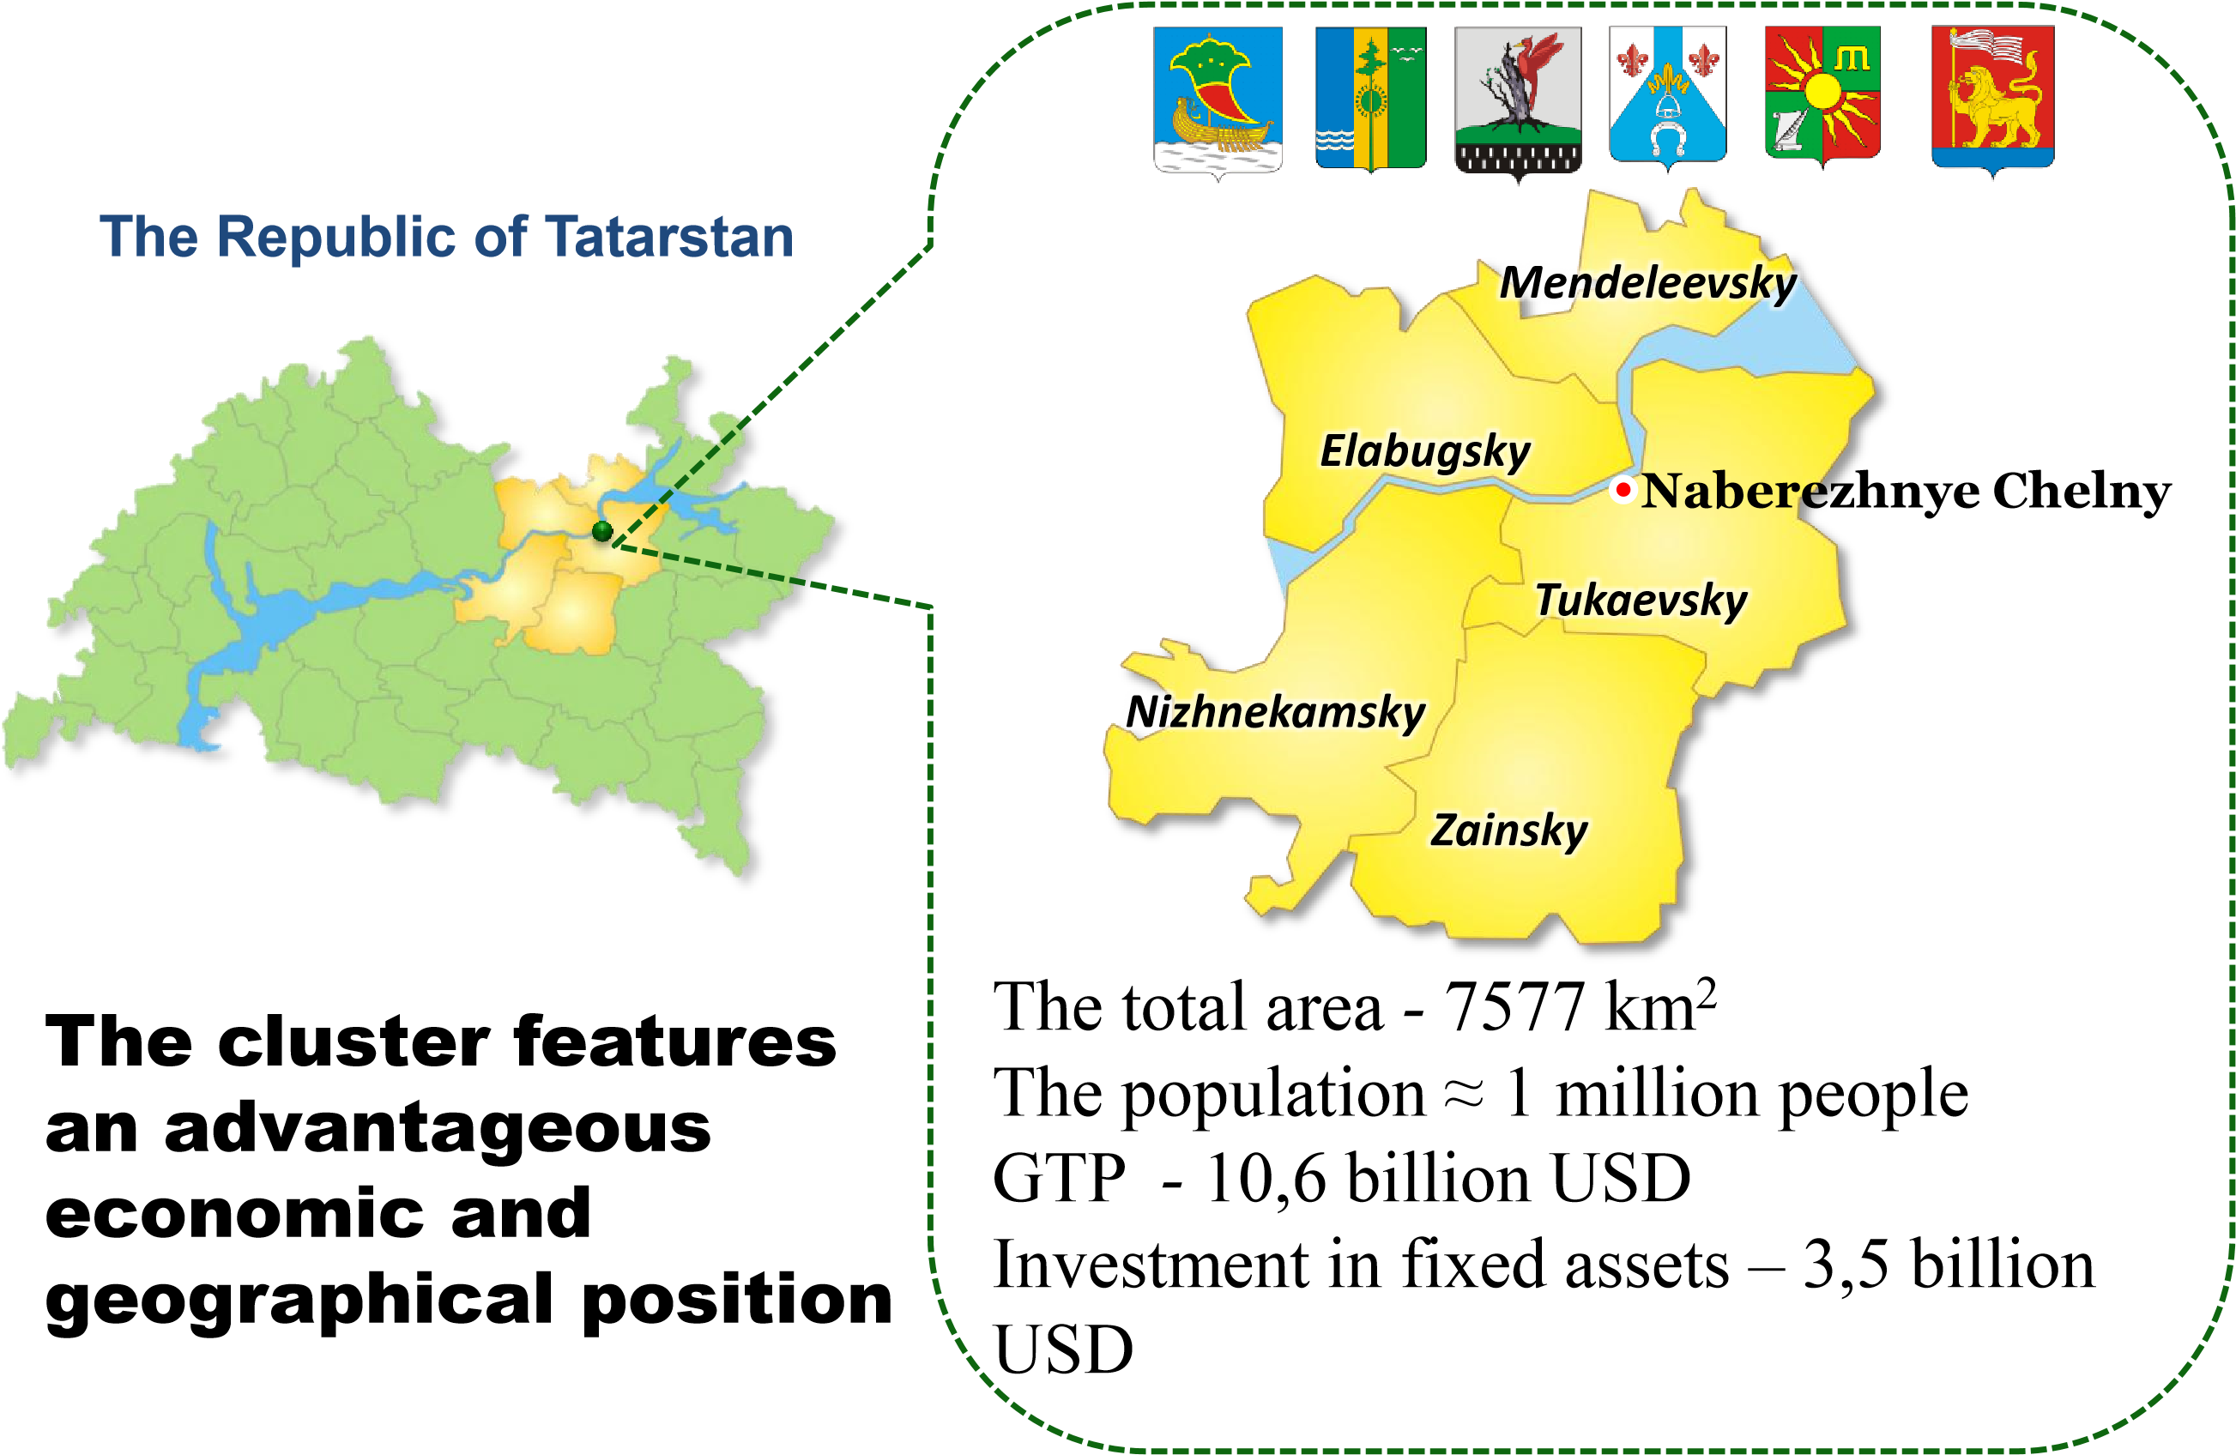

“Innopolis Kazan”
Concept: Live, Work, Learn, and Play

Site: 1,200 hectares
35 kilometers away from the Kazan downtown
Population: 150,000
The project is being implemented under the public-private partnership

Special Economic Zone “Innopolis”
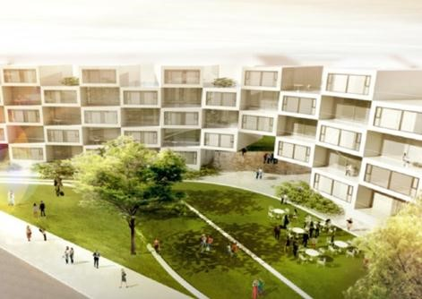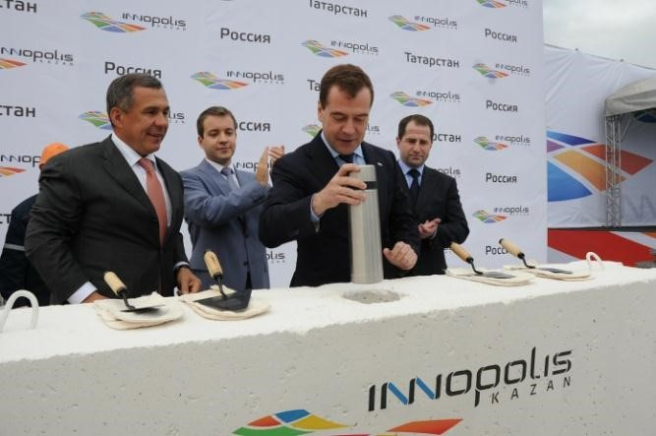

“Smart-city Kazan”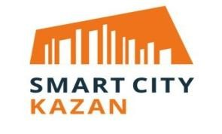
Concept: Global, smart sustainable city, a center of excellence for international business and knowledge development

Site: 650 hectares
15 kilometers away from the Kazan downtown
Population: 72,000
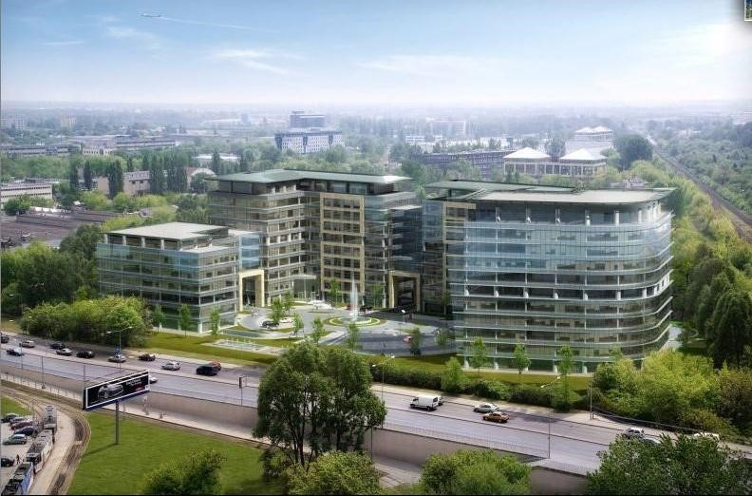

Investment projects
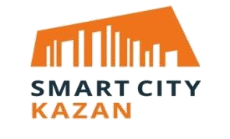
Complex of Oil-Refining and Petrochemical Plants in Nizhnekamsk with capacity of 7 mil. tons per year
Complex for production of ammonia, methanol and carbamide with total capacity of 1,4 mil. tons per year
Construction of ethylene production plant with total capacity of 1 mil. tons per year
Construction of heavy oil residue conversion complex
Design of highway tractor truck
Construction of satellite city “Innopolis”
Construction of satellite city “Smart City”

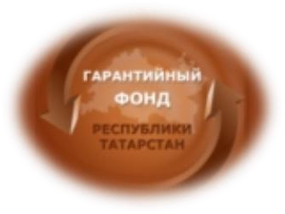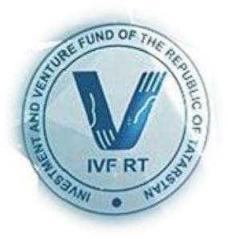
Investment and Venture Fund of the
Republic of
Tatarstan

Guarantee Fund of the Republic
of Tatarstan

Regional innovative

projects

fund
for AIRR (FAIRR)

Institutions of development the Republic of
Tatarstan

of the production
71% output $1.9 bln. USD

of tax
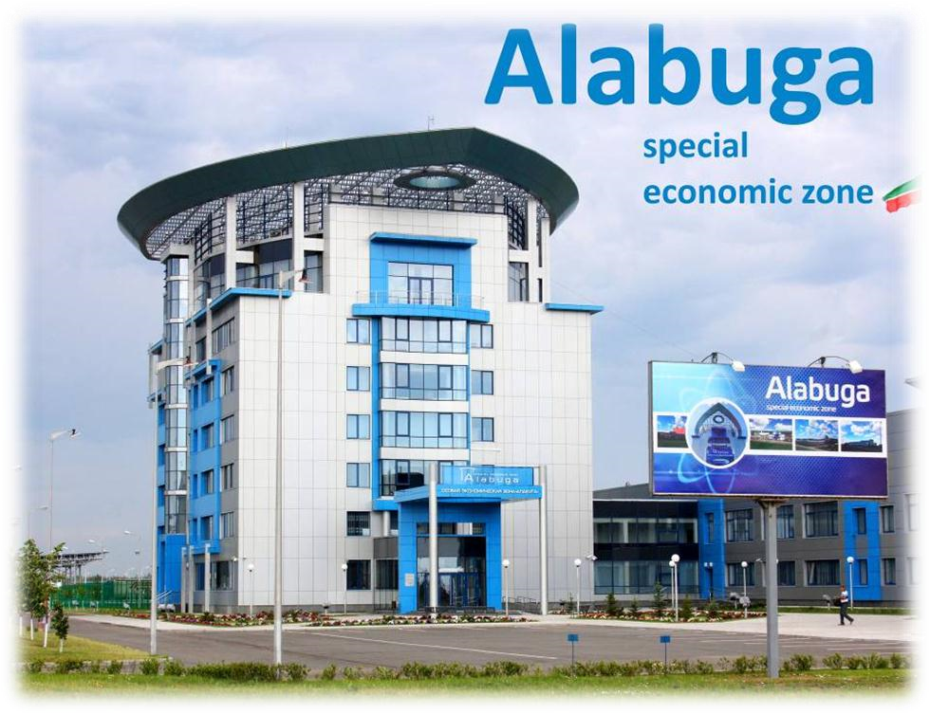
59% payments $ 147 mln. USD
SEZ “
Alabuga
”

in the structure of
special economic zones
(
out of 17 zones
):

54%
of investments
$ 1.2 bln. USD
Foreign companies in the Republic of Tatarstan
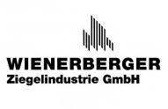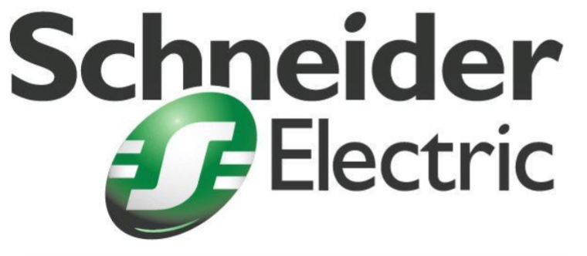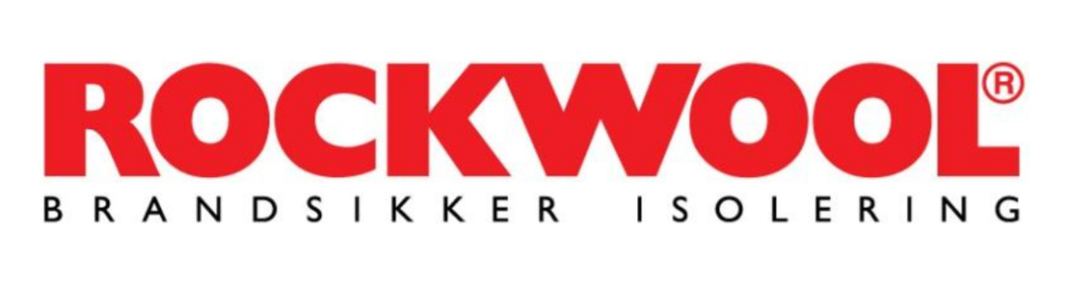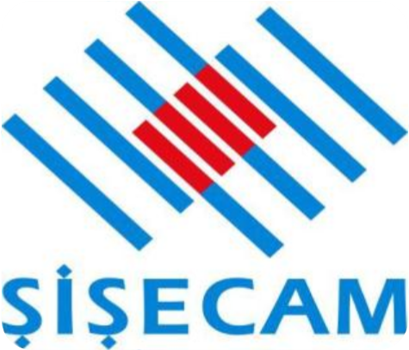
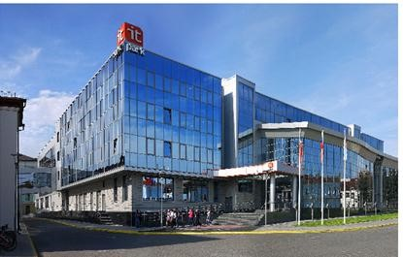
Technopark in the
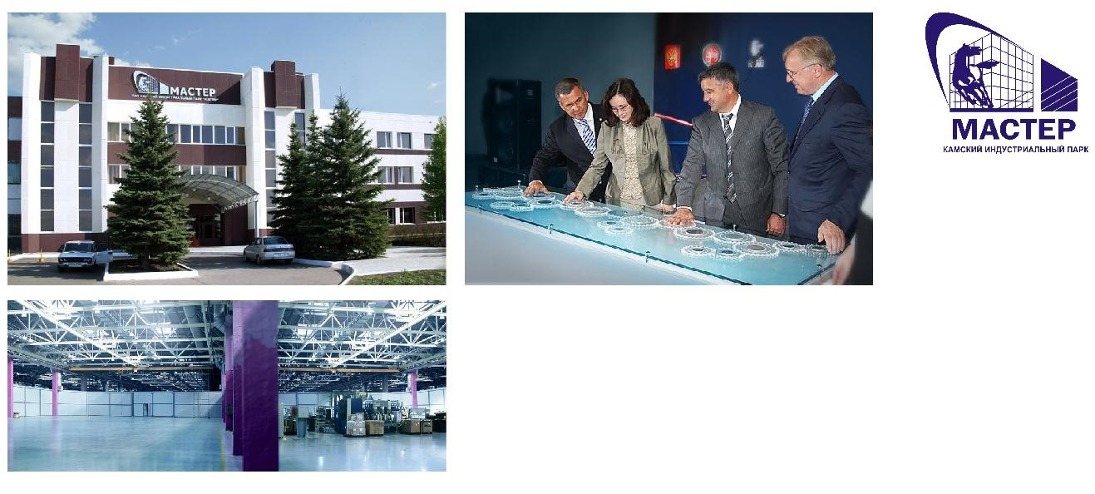
Sphere of High
OAO Kama Industrial Park Master

Technologies
(IT Park Kazan)

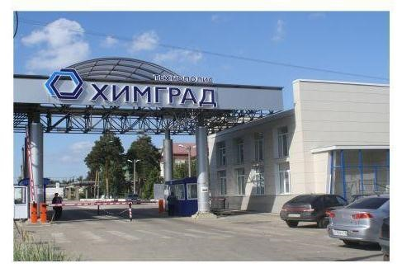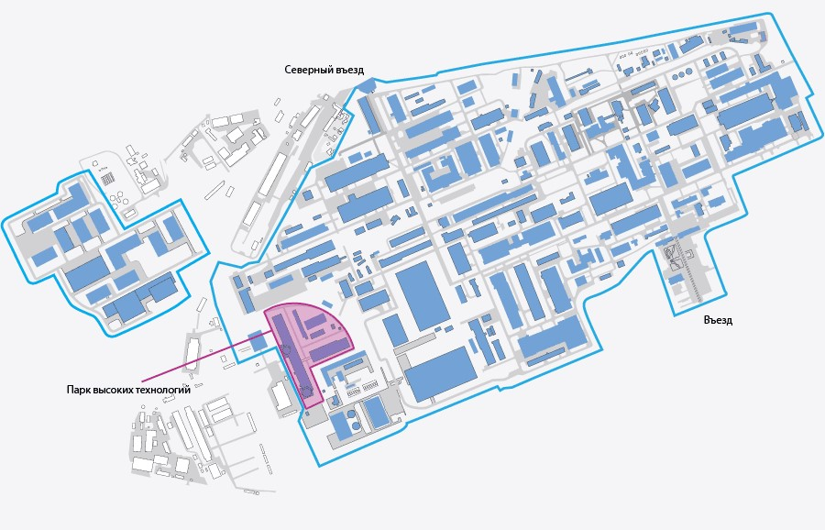

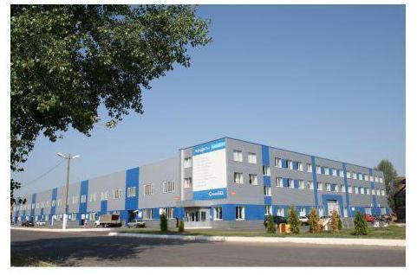
170 residents More than 5,000 employees Total area 131 hectares
Square 500,000 sq. m Volume of products manufactured in 2011 was $250 million Tax paid $56.5 million
-Regional Engineering Center of industrial laser technology «KAI - LASER»

-Regional Center for Engineering «Center of Medical Science «Eidos»

- Regional Center for Engineering in the field of
chemical technologies;
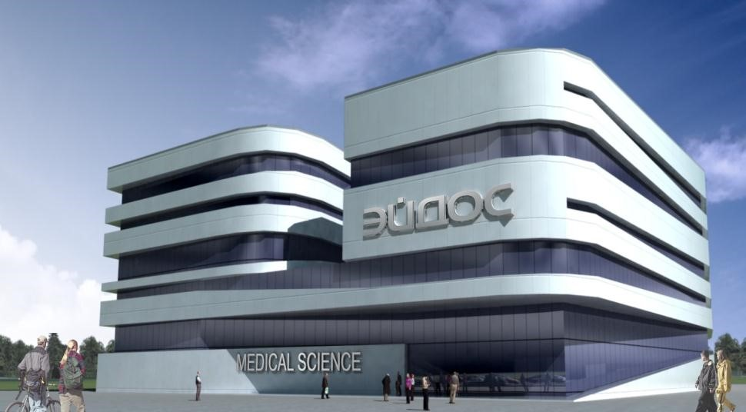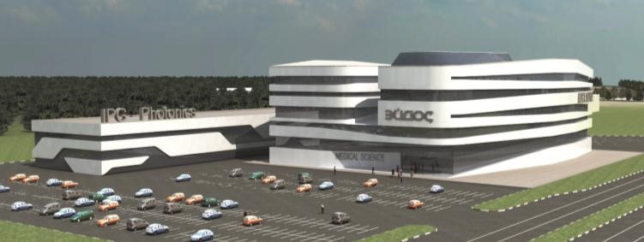
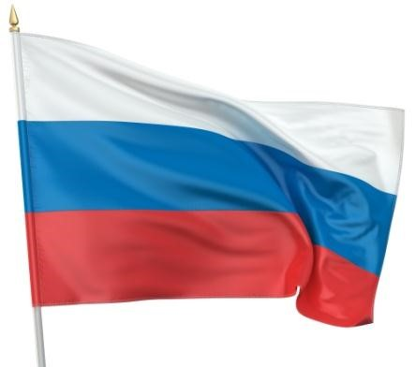
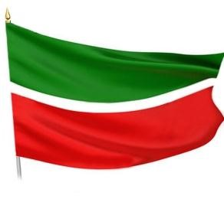
Thanks for your attention!
Russian Federation,  Republic of Tatarstan,  420021, Kazan,  Moskovskaya st., 55 | Telephone: +7 (843) 524-91-11 Fax: +7 (843) 524-91-23 e-mail: me.rt@tatar.ru www.mert.tatar.ru
15

